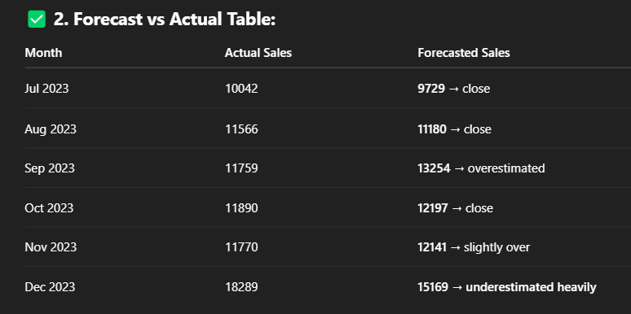
SARIMA (1,1,1)(1,1,1,12) results:

No of obs: 30
Log Likelihood: -20.155
AIC: 50.310
BIC: 45.803
HQIC: 41.250
ar.L1 = 0.4141, P>|z| = 0.990
ma.L1 = -1.0048, P>|z| = 0.400
ar.S.L12 = -0.8843, P>|z| = 0.852
ma.S.L12 = -0.9045, P>|z| = 0.983
sigma2 = 1.605e+04, P>|z| = 0.000

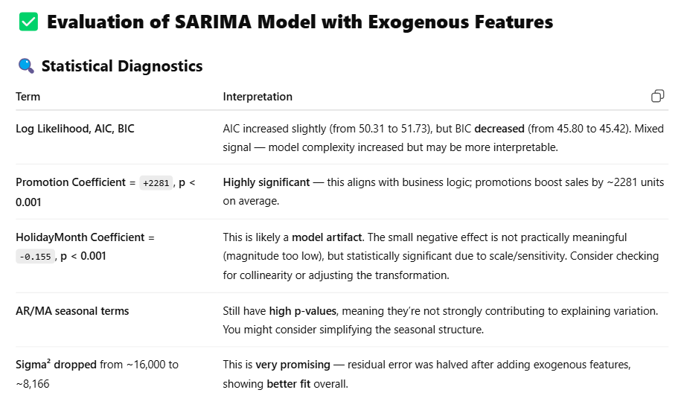
SARIMA (1,1,1)(1,1,1,12) with exogenous features (promotion and holiday month)

No of obs: 30
Log Likelihood: -18.866
AIC: 51.732
BIC: 45.423
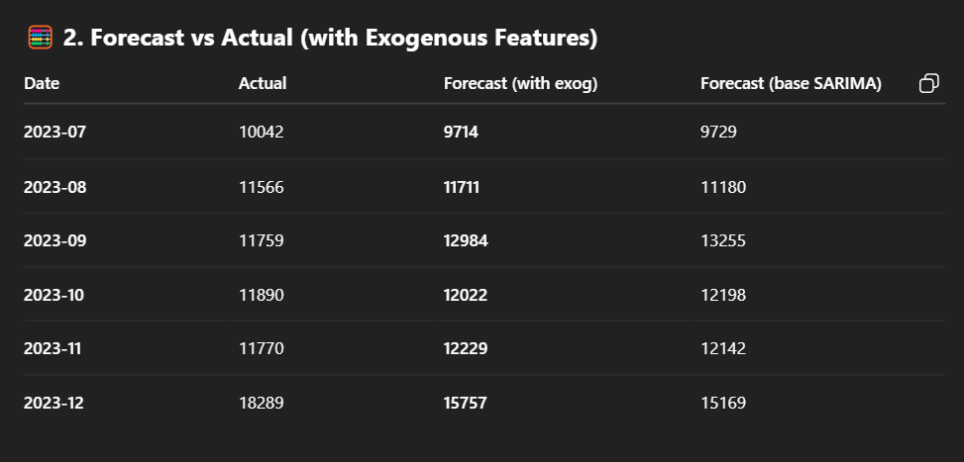
HQIC: 39.049
Coef value: Promotion = 2281.2763, P>|z| = 0.000
Coef value: HolidayMonth = -0.1553, P>|z| = 0.000
Coef value: ar.L1 = 0.4095, P>|z| = 0.779
Coef value: ma.L1 = -0.9479, P>|z| = 0.657
Coef value: ar.S.L12 = -0.6672, P>|z| = 0.123
Coef value: ma.S.L12 = 1.1419, P>|z| = 0.279
Coef value: sigma2 = 8166.5260, P>|z| = 0.000

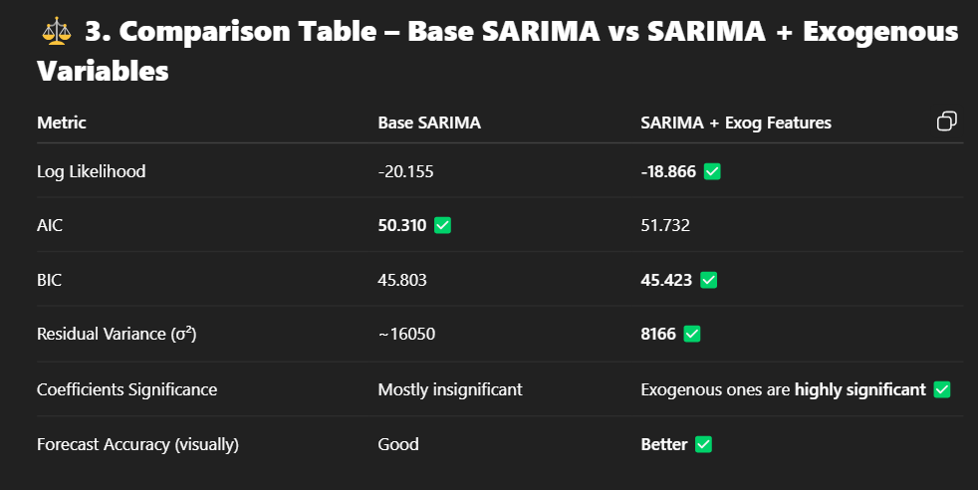

SARIMA (1,1,2)(1,0,1,12) with exogenous features (promotion and holiday month)
No of obs: 30
Log Likelihood: -109.536
AIC: 235.073
BIC: 240.185
HQIC: 234.599
Coef value: Promotion = 1794.0526 , P>|z| = 0.004
Coef value: HolidayMonth = 2007.7538 , P>|z| = 0.747
Coef value: ar.L1 = 0.1200 , P>|z| = 0.730
Coef value: ma.L1 = -2.0103 , P>|z| = 0.068
Coef value: ma.L2 = 1.0274 , P>|z| = 0.346
Coef value: ar.S.L12 = 0.8622, P>|z| = 0.000
Coef value: ma.S.L12 = 0.7741, P>|z| = 0.681
Coef value: sigma2 = 1.815e+05 , P>|z| = 0.000

SARIMA (2,1,2)(0,1,0,12) with exogenous features (promotion and holiday month)
No of obs: 30
Log Likelihood: -111.10
AIC: 236.619
BIC: 241.093
HQIC: 236.205
Coef value: Promotion = 2443.6798 , P>|z| = 0.000
Coef value: HolidayMonth = 12.2272, P>|z| = 1.000
Coef value: ar.L1 = -0.2834, P>|z| = 0.441
Coef value: ar.L2 = -0.6134, P>|z| = 0.106
Coef value: ma.L1 = -6.9165 , P>|z| = 0.967
Coef value: ma.L2 = 1.7343, P>|z| = 0.979
Coef value: sigma2 = 1.013e+04, P>|z| = 0.984

